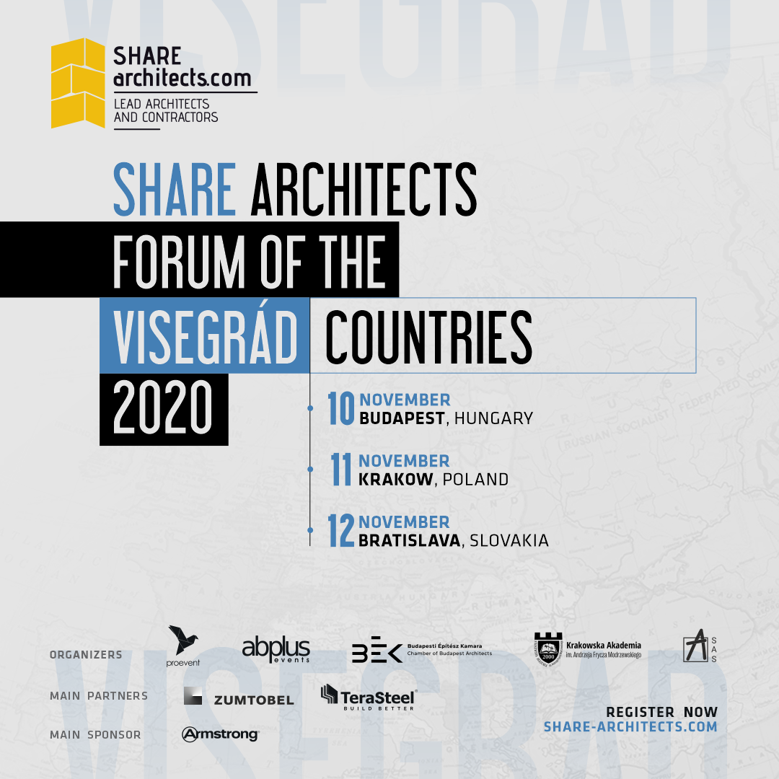
SHARE Bratislava 2020
Association of Architects of Slovakia is pleased to announce the International Architecture and Engineering Forum organized together with SHARE Architects in the virtue of the partnership, towards the promotion and development of Slovakian Architecture.
SHARE Bratislava 2020 will take place on the 12th of November 2020, as part of an ample forum dedicated to architects in Central Europe between the 10th - 12th of November. Entitled SHARE Architects forum for the Visegrad Countries, the event will develop throughout the three days as follows:
10th of November in Hungary, 11th of November in Poland, 12th of November in Slovakia and the Czech Republic
The Forum will focus on challenges and new opportunities of contemporary architecture, with a complex program including projects and speakers with outstanding results in architecture.

Headline speakers on Slovakia and the Czech Republic's DAY
Juraj HERMAN - President Association of Architects of Slovakia - SLOVAKIA
Oleg HAMAN - President Czech Society of Architects - CZECH REPUBLIC
Vicente GUALLART - Co-founder Institute for Advanced Architecture of Catalonia, Founder Guallart architects - former chief architect of Barcelona City Council
Tobias WALLISSER - Co-founder LAVA – GERMANY - Vice-President at the State Academy of Fine Arts in Stuttgart
Julian WEYER - Partner C.F. Møller Architects – DENMARK – internationally awarded studio
Vlad GAIVORONSCHI - architect ph.d , professor, Co-founder Andreescu and Gaivoronski – ROMANIA – internationally awarded studio
Vit HALADA & Benjamín BRÁDŇANSK - Founding partners N/A - SLOVAKIA
Jaroslav WERTIG - Co-founder A69 - CZECH REPUBLIC
Michal BOGÁR - Founder BOGÁR architekti – SLOVAKIA
Participants registered at the forum will be able to attend all conference days.The complete agenda and an overview of all guest speakers is available at this link https://share-architects.com/share-bratislava-2020-about/
WHOVA - an online dedicated platform
The entire SHARE Bratislava 2020 event can be watched live on the dedicated online platform - Whova. Accessing the platform can be done both on the mobile phone and on the desktop and it is only allowed to registered participants and speakers. Even in times of the COVID-19 pandemic, it offers the ideal platform to maintain contacts, share information, give business a boost, and discuss the latest issues.
Register for FREE to SHARE Bratislava 2020
https://share-architects.com/share-bratislava-2020-about/
You will be able to login to a dedicated online platform to benefit from:
- Live keynote speeches, panel debates and workshops;
- Opportunity for live Q&A with speakers;
- Access to recordings, videos and slide decks after the event;
- Round tables and fun interactive breakouts;
- Direct messaging with other attendees;
- Virtual exhibition hall access and business card exchange;

About SHARE architects
The SHARE Forum has created in the past 23 years an essential networking platform for professionals in the AEC (architecture, engineering, and construction) industries from Central and Eastern Europe. The forums create an efficient platform for getting in contact with and understanding the diversity of the contemporary architectural phenomenon. Presently, the SHARE events are held in 15 countries from Central and Eastern Europe and the SHARE Community has over 50.000 members worldwide.
For customer service, bookings, and sponsorship opportunities please contact us at share@abplusevents.com

